Current State Initiatives: 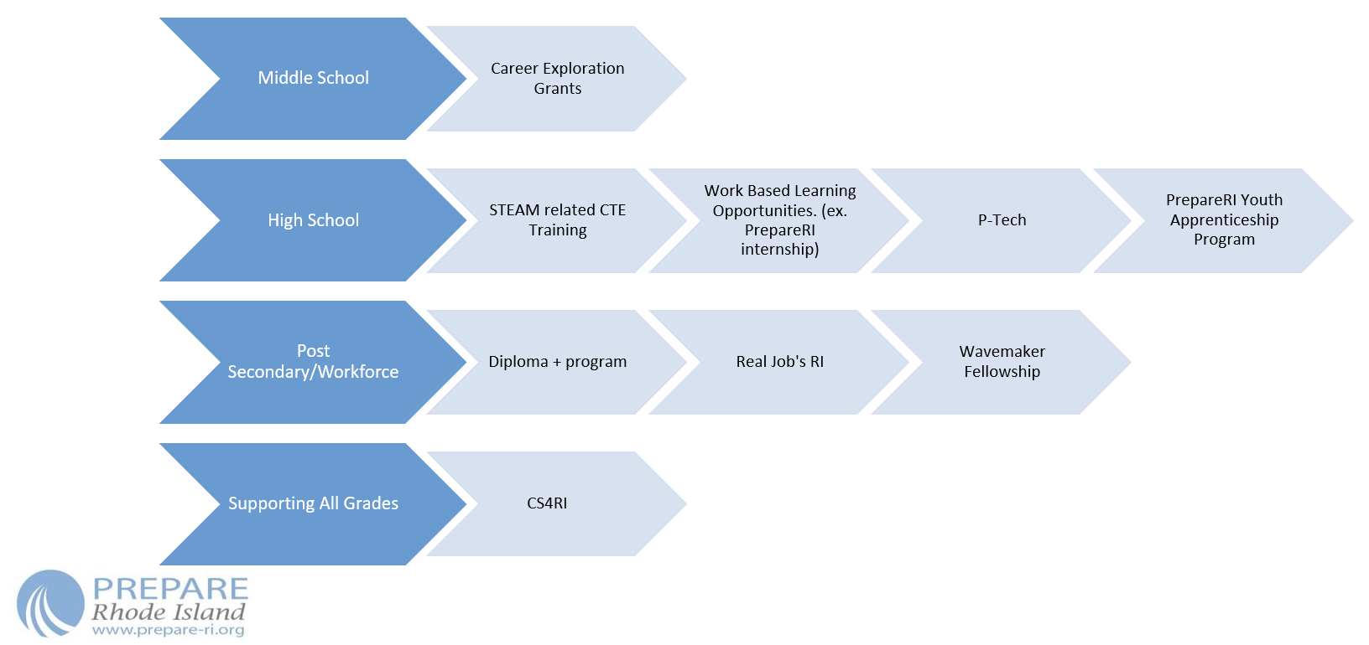

Key Programs and Stakeholders:
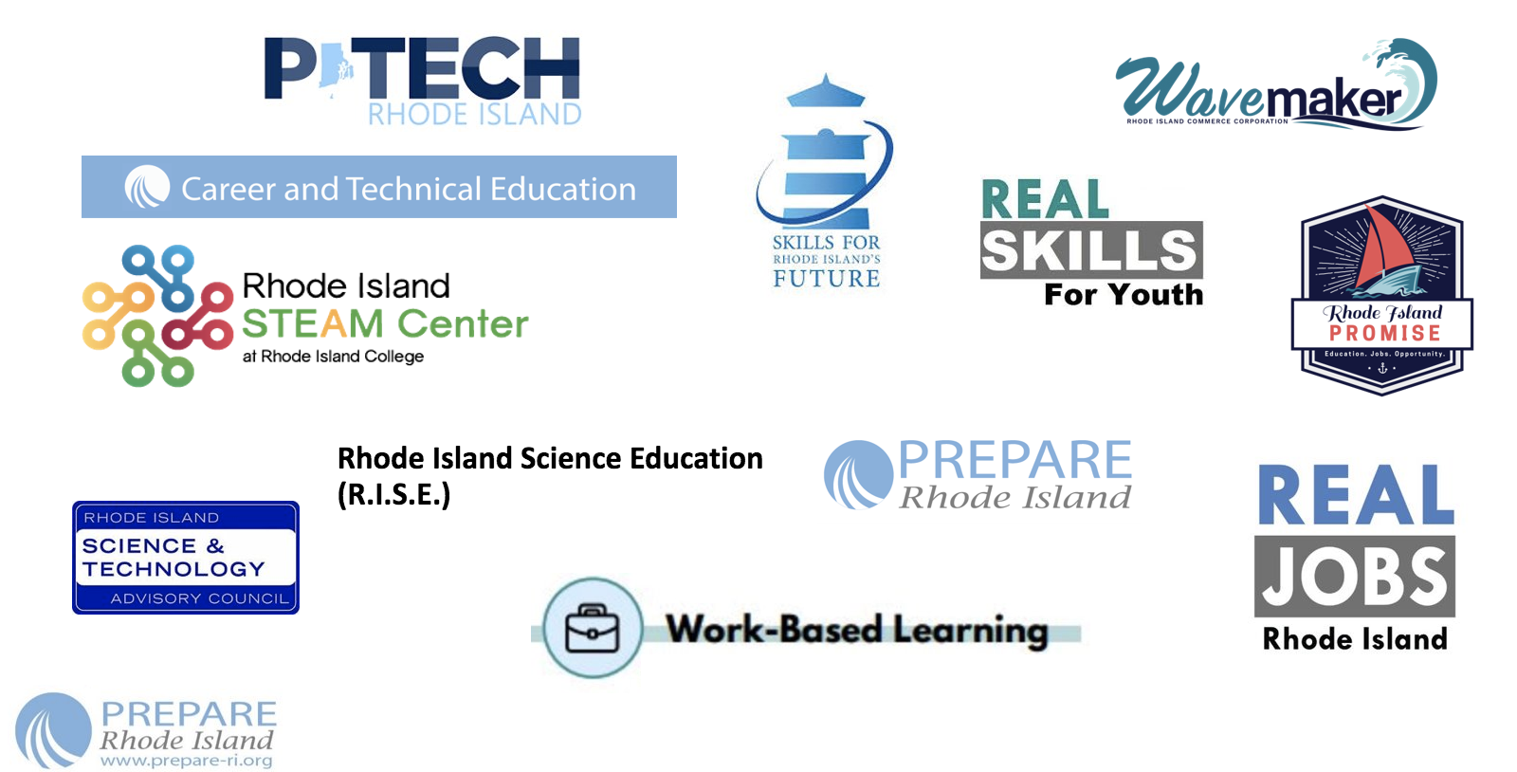

Question:
- Are we missing anything from this list?
  - Are there initiatives related to STEAM happening across Rhode Island that are not represented here?

